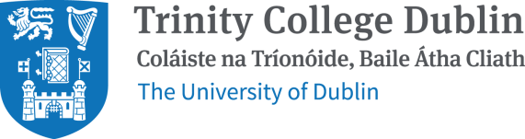

Contractor/Visitor Covid-19 Questionnaire
To ensure the Safety & Health of all people interacting within Trinity College Dublin, visitors and contractors are requested to complete this declaration form prior to entering the Campus.

Please be advised, that in the interest of the safety, health and welfare of you, your colleagues and the college community, you will be prohibited from entering the campus if you answer Yes to questions 1-7 below.
If you indicate on the form to have symptoms of COVID-19 OR you have been advised to self-isolate, restrict movements or quarantine, you are prohibited from entering the Campus.

Visitor/Contractor Covid-19 Questionnaire
Name:
Company:
Mobile No.:
Visiting:
Date:

 | Question | Yes | No
1 | Have you been diagnoised with confirmed/suspected Covid-19 infection  or been advised, by a doctor, to self-isolate within the last 14 days?
2 | Have you been in close contact with a confirmed/suspected case of  Covid-19 in the past 14 days (i.e. less than 2 meters for more than 15 minutes accumulaive 1 day?
3 | Do you have any of the following typical Covid-19 symptoms; fever, high temperature, persistent coughing or breathing difficulties/shortness of breath, sore throat, runny nose or loss or change to your sense of smell  or taste now or in the past 14 days ?
4 | Are you awaiting the results of a Covid-19 test?
5 | Have you been advised to restrict your movements at this time?
6 | Have you been advised to self-isolate at this time?
7 | Are there any other circumstances relating to Covid-19, not included in the above, which may need to be considered to allow you to attend  college?
8a | Have you returned to the island of Ireland from another country in the  last 14 days?
8b | If YES, please state if they have complied with the requirements for travelling to Ireland as outlined by the Department of Justice prior to travelling.

Additional Comments:

Rev.6 July 2021

